**Rotation of hysteresis loops**

The forward and reverse branches of the hysteresis loop are obtained by integrating the signal synchronously with the applied scanning magnetic field. If the ground level of the signal relative to which it is measured is not ideally zero, then as a result of integration, there will be a slope of the branches. Depending on the measurement method, a non-zero ground level is due either to the non-equivalence of the signals from the two differential pick-up coils (“longitudinal loops”) or to the incomplete balance of the bridge circuit (“circular loops”). Achieving full compensation of the ground level is quite difficult, but often, this effect is small and can, in principle, be neglected. However, if the slope of the branches becomes noticeable, it is advisable to take measures to compensate for the errors accumulated during integration. This can be achieved by introducing DC offset levels to compensate for non-zero ground levels.

Fig. 1 displays a loop measured from a bridge circuit where the slope of the branches is too pronounced to ignore. We deliberately omit the units of measurement for the fields along the axes, as the issue of choosing scales has not yet been resolved. However, this omission does not affect the shape of the loops in any way.

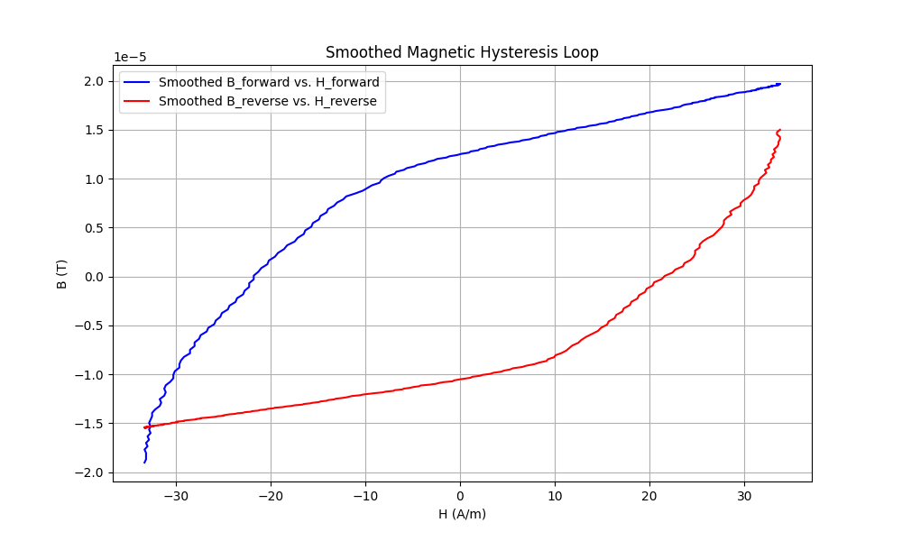

**Fig. 1.** The forward and reverse branches of hysteresis, which require a turn to form a closed loop.

Formulating a criterion for the magnitude of rotation needed for the branches is challenging, particularly when the ground level exhibits non-linear behaviour in addition to vertical displacement. In our algorithm, we have implemented a basic method involving the introduction of constant offsets to the ground. This results in either a positive or negative slope during integration for the forward and reverse branches.

The circular hysteresis loop shown in Fig. 1 was generated through the integration of the signal illustrated in Fig. 2. Fig. 2 also displays the sine wave of the driving signal along with reference points indicating the beginning and end of the integration processes. Regarding the ground level, the following observations can be made: it is non-zero, exhibits non-linear behaviour, and is bipolar for forward and reverse integrations. Clearly, the current passing through the wire in the bridge circuit was insufficient to attain the desired saturation, consequently leading to less certain integration.

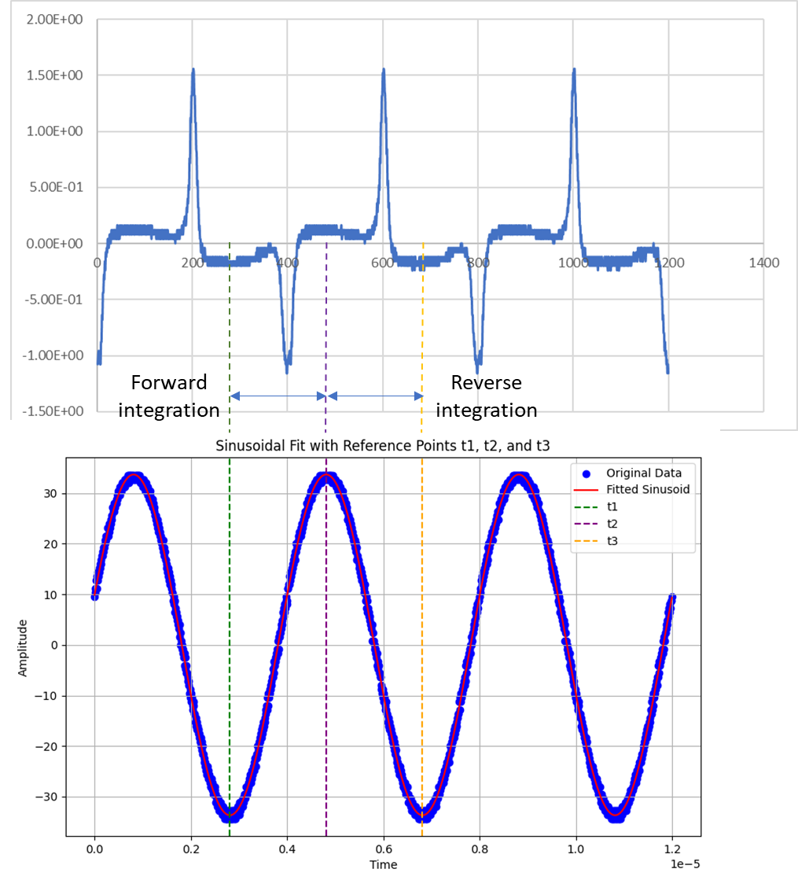

**Fig. 2.** The signal, integrated to produce the hysteresis loop in Fig. 1.

For the signal in Fig. 2, our only recourse is to attempt the introduction of two compensating DC offsets for forward and reverse integration (“groundf” and “groundr”). In the algorithm, this is represented as follows:

1. # Forward integration of the voltage response between the reference indexes 1 and 2

2. B_forward = []

3. H_forward = []

4. integral_value = 0.0

5. for i in range(refindex1, refindex2):

6. H_forward.append(sinusoid_fit[i]) # Values taken from the fitting sinusoid

7. # H_forward.append(sin_values[i]) # Experimental values (old version)

8. for j in range(refindex1, i):

9. integral_value += 0.5 * (response_values[j] + response_values[j + 1]) * time_increment # Trapezoid method

10. integral_value += - groundf * (j - refindex1 + 1) * time_increment # ground offset compensation

11. B_forward.append(integral_value)

12.

13. # Reverse integration of the voltage response between the reference indexes 2 and 3

14. B_reverse = []

15. H_reverse = []

16. integral_value = 0.0

17. for i in range(refindex2, refindex3):

18. H_reverse.append(sinusoid_fit[i]) # Values taken from the fitting sinusoid

19. # H_reverse.append(sin_values[i]) # Experimental values (old version)

20. for j in range(refindex2, i):

21. integral_value += 0.5 * (response_values[j] + response_values[j + 1]) * time_increment # Trapezoid method

22. integral_value += - groundr * (j - refindex2 + 1) * time_increment # ground offset compensation

23. B_reverse.append(integral_value)

At the same time, there are no physically justified criteria for determining the magnitude of these offsets. Therefore, one must rely solely on common sense and experience when making such selections. If the resulting loops continue to be unsatisfactory from a physical standpoint, then additional signal processing measures must be employed to enhance the ground level of the measured signal.

In Fig. 3 below, we present two rotation scenarios corresponding to different offset levels. It is conceivable to rotate further; however, doing so results in non-physical loop shapes. Therefore, the compensating offset method has limited applicability. General recommendations for measuring loops are as follows:

* Increase the amplitude of the excitation signal to achieve better saturation, and consequently, a more reliable ground level.
* Enhance balancing methods.
* Propose practical methods for compensating nonlinear ground level distortions (e.g., employing filters).

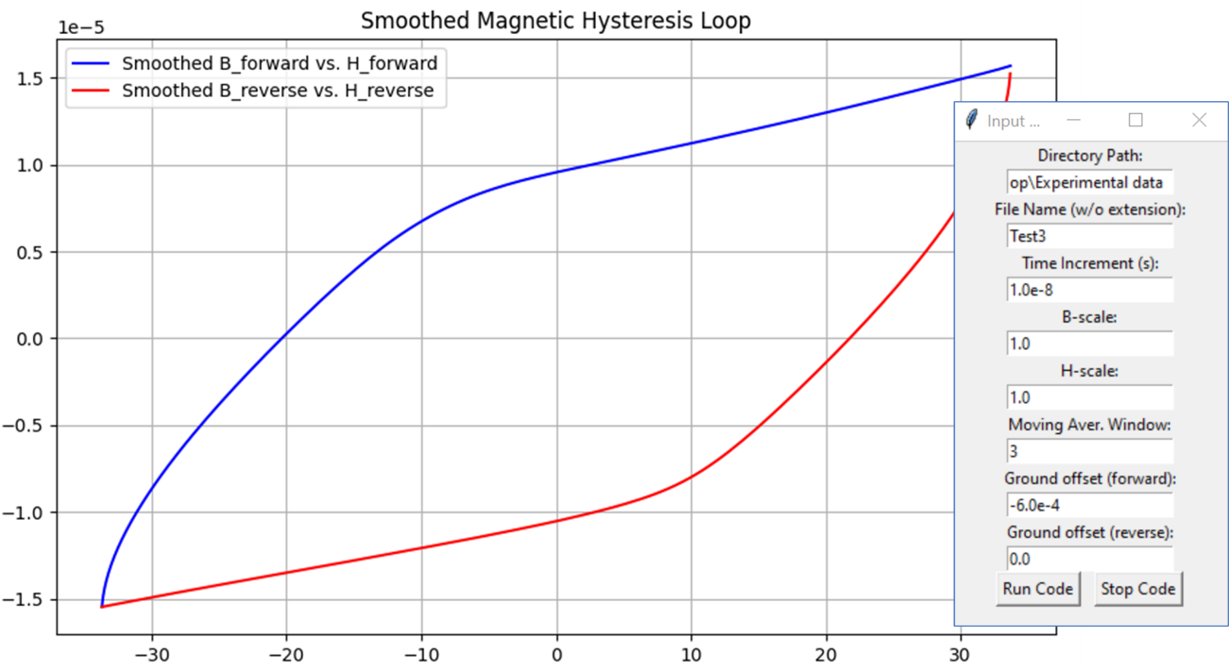

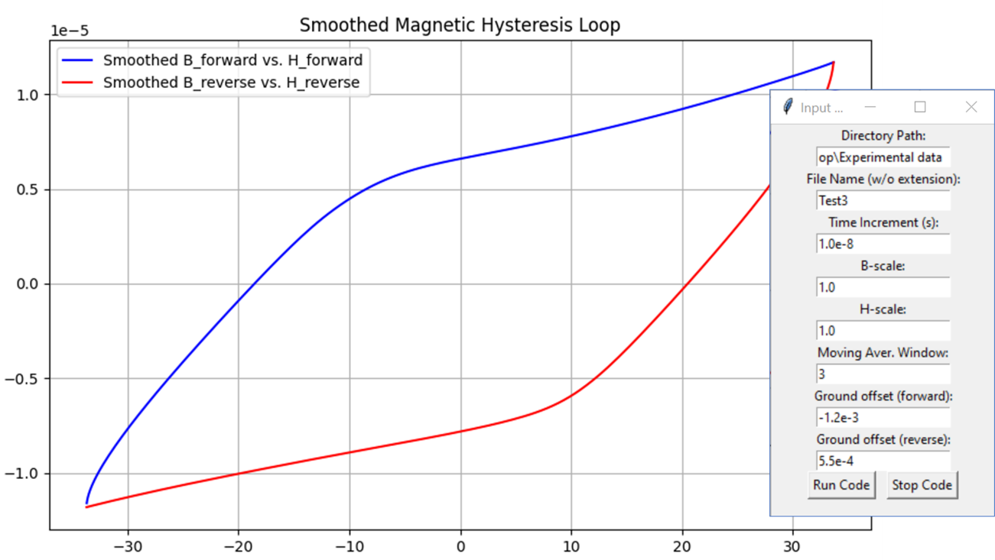

**Fig. 3.** Two rotation scenarios corresponding to different offset levels.